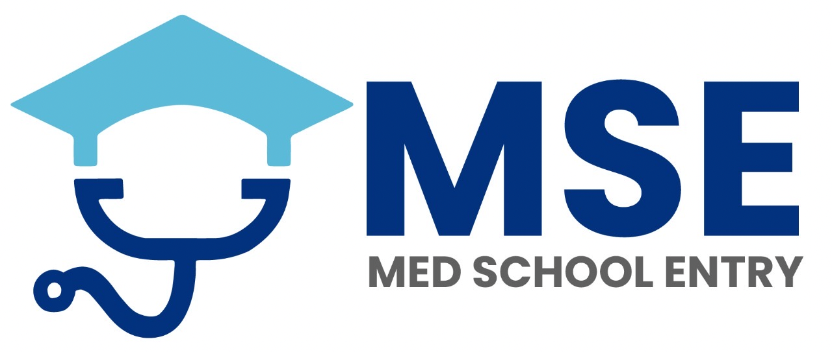

MEDSCHOOLENTRY
ESSAY COMPETITION
STUDENT SUBMISSION FORM
For Aspiring Medical & Dental Students

STUDENT DETAILS
Full Name:
Date of Birth:
Email Address:
School / College:
Applying for: Medicine ☐ Dentistry ☐
UCAS Cycle (e.g., 2026 entry):

ESSAY TITLE (tick one)
☐ Prevention Is Better Than Cure: How Can Medicine and Dentistry Reduce Health Inequalities
☐ Artificial Intelligence in Healthcare: Tool, Threat, or Transformation?
☐ Autonomy vs Beneficence: Should Doctors and Dentists Ever Override Patient Choice?

ESSAY SUBMISSION
Please send your essay and this completed form with the Subject heading -ESSAY COMPETITION 2026 to info@medschoolentry.uk
Maximum length: 4,000 characters
Standard academic referencing required (Harvard or Vancouver)

WHY THIS MATTERS
This essay may be referenced in your UCAS personal statement and discussed at interview as an independent mini research project, regardless of whether you win the competition.

PRIZES
1st Prize
A FREE place on Dr Khan’s ULTIMATE 12‑Week Medical & Dental Interview Course
Worth £750
2nd Prize
A FREE place on our 8‑Week UCAT Course
Worth £640
Led by some of the highest‑scoring UCAT candidates in the UK/ Australia.
3rd Prize
Complete Personal Statement Package
Top‑tier service worth £350

ACADEMIC INTEGRITY DECLARATION
By submitting this essay, I confirm that:
• This work was NOT generated by AI
• No external support (paid or unpaid) was used
• This is entirely my own original work
• All sources have been clearly and accurately referenced

Student Signature:
Date:

JUDGING PANEL
Dr Rizvia Khan
BSc (Hons) MBChB FRCGP DFFP (O8) PGCert (TIPC) MRCPath (ME) MFMLM
GP, Senior NHSE Leader and Lead Appraiser for London
Adjudicator of last year’s submissions
Dr Samia Khan
BDS PGCert Operative and Aesthetic Practice. Lead Dental Principal
MEDSCHOOLENTRY
Consultant‑led. Trusted by Doctors. Proven by Students.

